**Title:** Freight Map Application – 2011

**Link:** <http://hqolymgis21t/GeoPortal/?config=freight>

**Description:** A browser based mapping application that provides visual access to Freight related data.

**Audience:** WSDOT Internal Staff

**Purpose:** Provide WSDOT staff with easy and free access to the Truck Performance Measure Data and Freight related information. This data is managed by the WSDOT Freight office.

**Features:**

* Freight Layers (Truck Performance Measures)
  + 1. Average Speed
    2. Bottleneck Puget Sound
    3. Bottleneck Statewide
    4. Reliability Puget Sound
    5. Reliability Statewide
    6. Severe Speed Threshold
    7. WSDOT Freight and Goods (not part of TPM data)
    8. AADT (not part of TPM data)
    9. AADT Truck Percentage (not part of TPM data)
* Multiple BaseMaps to use for reference:

1. WSDOT Basemap
2. Imagery
3. Functional Class
4. Terrain
5. Topography
6. Streetmap
7. Shaded Relief

* General WSDOT Themed Layers

1. State Routes
2. Interchange Drawings,
3. City limits,
4. Region Boundaries
5. Congressional Districts,
6. County boundaries,
7. Legislative Districts
8. MPO
9. RTPO
10. Township
11. Tribal Areas
12. Maintenance Areas
13. Survey Monuments
14. Functional Class

* Ability to locate State Route, Milepost and ARM
* Find an Address
* Measure Tool (Find X,Y of a point, measure line distance, measure area)
* Export Graphics
* Share a location with other users by providing a URL link
* Access to Metadata
* Zoom Controls

**Detailed Description for the Freight Layers:**

**Data source, collection and analysis method**

Except the AADT Truck percentage, WSDOT Freight and Goods, and AADT layers, all the rest data layers under “Freight” Tab were developed based on the truck GPS data.

The truck GPS data was collected for one year (September 2010 to September 2011) from about 6,000 GPS-equipped trucks per day traveling on roads throughout Washington State. The commercial in-vehicle GPS devices report, via cellular technology, both at preset intervals (every 10 to 15 minutes) and when the trucks stop. The resulting GPS data set includes reads for individual truck’s longitude and latitude, the truck’s ID (scrambled for privacy), spot (instantaneous) speeds, and a date and time stamp.

Utilizing geographical information system (GIS) techniques, the state’s roadway network was partitioned into individual segments at following locations: access ramps, changes in posted speed limit, county boundaries, urban/rural area boundaries, and signalized intersection. Then the truck GPS data was assigned to these segments to evaluate the roadway performance. The performance analysis was only conducted for the segments with enough GPS truck data reads for a valid analysis—a minimum of a 200 trucks per segment. Three performance measures were adopted:

* **Average Speed:** this measure calculates the average speed for trucks based on the truck spot speeds collected over each freeway segment.
* **Frequency of truck speed falling below 60 percent of posted speed:** this measure calculates the percentage of truck spot speeds falling below 60 percent of the posted speed limit. 60 percent of posted speed was selected as the threshold because it is used in WSDOT congestion report as the speed threshold for evaluating whether the freeways are experiencing severe congestion.
* **Travel Reliability**: The reliability evaluation criteria examine whether the travel conditions during a given time period (in the central Puget Sound region) or a given day (in the non-Puget Sound areas of the state) are reliable, given the speed distribution and a statistical fitting process. Generally speaking, if the speed distribution has two speed “humps” and is bimodal (such as in Figure 1a), then the travel condition is considered unreliable. Otherwise, the travel condition is unimodal and is considered reliable with one average speed (as in Figure 1b).

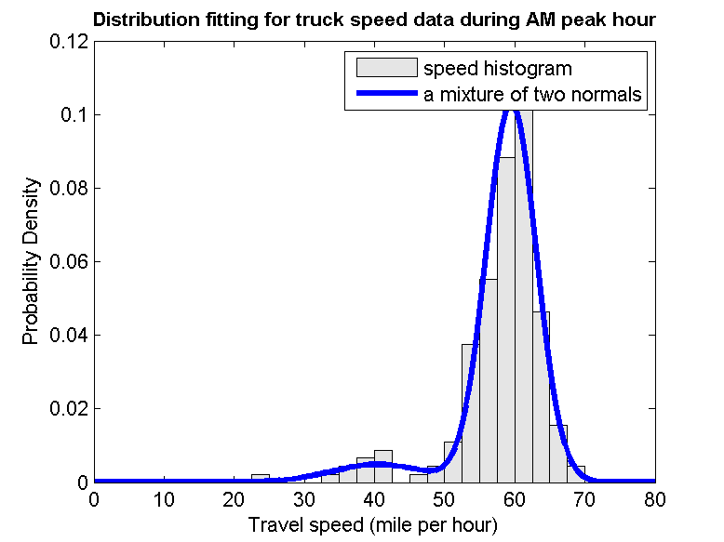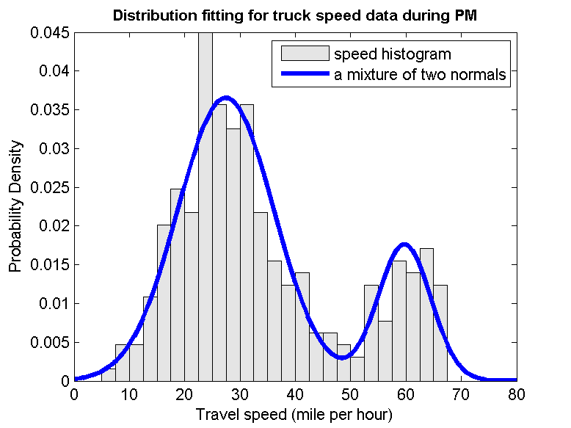

**Figure 1: Speed Distribution: (a) speed distribution with a bimodal feature (b) speed distribution with a unimodal feature.**

The evaluation process separates Washington State into Puget Sound area and the rest of the state (referred as statewide). That is because the methodology adopted for Puget Sound and statewide is different and therefore the performance measures for two parts are not comparable. For Puget Sound area, the GPS data collected during night time was excluded from the dataset for performance analysis, while for statewide, 24 hour data was used for analysis.

Those three measures are used to identify and rank truck bottlenecks in Washington State. Roadway segments with unreliable travel condition for trucks are perceived as truck bottlenecks. The bottlenecks are separated into Puget Sound bottlenecks and statewide bottlenecks, and then further subdivided by Freight Corridor Classifications. The classification is based on the average annual gross tonnage carried by the roadway:

* The super T-1corridor (carrying more than 20.5 million tons per year)
* T-1 corridor (10 million to 20.5 million tons per year)
* T-2 (4 million to 10 million tons per year)
* T-3 (300,000 to 4 million tons per year)
* T-4 (100,000 to 300,000 tons per year)
* T-5 (at least 20,000 tons in 60 days)

Truck bottlenecks are ranked based on following criteria:

1. Rank PSRC bottlenecks by total number of unreliable performance periods (throw out nighttime period); Rank statewide bottlenecks with all those segments with unreliable performance at top.
2. Rank bottlenecks by percentage of truck travel speed falling below 60 percent of posted speed.

Bottlenecks are only compared within the same freight roadway (FGTS) classification, and a separate ranking list is developed for each category.

*The data collection is an on-going process and these layers are updated regularly when new GPS data becomes available. Please check* [*http://www.wsdot.wa.gov/NR/rdonlyres/B7A5D60C-BF99-412F-9444-BA513768DC93/0/TPMFinalreportver2_17June2011.pdf*](http://www.wsdot.wa.gov/NR/rdonlyres/B7A5D60C-BF99-412F-9444-BA513768DC93/0/TPMFinalreportver2_17June2011.pdf) *for detailed information about Truck Performance Measure Project.*

**Definition and Symbology of Freight Data Layers**

**AADT Truck percentage:** this layer displays the truck percentage of Annual Average Daily Traffic volumes in 2010 collected by WSDOT Statewide Travel and Collision Data Office for the State Highway System.

Truck percentage is represented with graduated colors on the map and grouped into three classes: truck percentage under 10%, between 10% to 20%, and truck percentage over 20%.

**Average Speed:** this layer displays the average truck speed calculated from truck GPS data. Average speed for PSRC roadway network is calculated based on the truck spot speeds collected over each freeway segments from 6 am to 7 pm during weekdays (night data collected from 7 pm to 6 am were excluded for analysis). The average speed for other areas of the state is based on 24 hours’ weekday speed data. Since the methodology adopted for Puget Sound and statewide is different, the performance measures for Puget Sound and for statewide (other areas of the state) are displayed on separate sublayers and are not comparable.

Average speed is represented with graduated colors on the map and grouped into seven classes. The class is equal sized and each represents a range of 10 mph.

**Bottleneck Puget Sound:** this layer displays the truck bottlenecks identified in PSRC area. Sub layers were created for the 20 worst bottlenecks and the other bottlenecks for each classification of FGTS freight corridors. The bottlenecks are subdivided by FGTS classification, and ranked based the following criteria: 1) rank by number of unreliable performance periods (throw out nighttime period). 2) rank by “percentage of truck speed falling below 60% of posted speed”.

Bottlenecks are represented by two colors on the map. The worst 20 bottlenecks for each Freight corridor classification are represented by red, and the other bottlenecks are represented by blue.

**Bottleneck Statewide:** this layer displays the truck bottlenecks identified in other areas of the state. Sub layers were created for the 20 worst bottlenecks and the other bottlenecks for each classification of FGTS freight corridors. The bottlenecks are subdivided by FGTS classification, and ranked based the following criteria: 1) rank with all those with unreliable performance at the top; 2) rank by “percentage of truck speed falling below 60% of posted speed”.

Bottlenecks are represented by two colors on the map. The worst 20 bottlenecks for each Freight corridor classification are represented by red, and the other bottlenecks are represented by blue.

**Reliability Puget Sound:** this layer displays the truck travel reliability during three different time periods (AM, midday, and PM) in PSRC. The travel reliability was evaluated based on truck speed distribution. If the truck speed distribution is unimodal and only has one peak (figure 1a), the roadway segment is reliable; if the truck speed distribution is bimodal and has two peaks (figure 1b), the roadway segment is unreliable.

Reliability is represented by two colors on the map. “Unreliable” is represented by red, and “Reliable” is represented by green.

**Reliability Statewide:** this layer displays the truck travel reliability in other areas of the state. The travel reliability was evaluated for the 24-hour time period.

Reliability is represented by two colors on the map. “Unreliable” is represented by red, and “Reliable” is represented by green.

**Severe Speed Threshold:** this layer displays the percentage of truck speed falling below 60 percent of the posted speed. For the PSRC area, night data was excluded to calculate this measure; for the rest of the state, 24 hour data was used for evaluation.

Severe Speed Threshold is represented with graduated colors and grouped into five classes. The class if equal sized and each represents a range of 0.2.

**WSDOT Freight and Goods:** this layer displays the classification of state highways, county roads, and city streets according to the average annual gross tonnage they carry in 2009. The roadways are classified into six different categories:

* super T-1 (more than 20.5 million tons per year)
* T-1 (10 million to 20.5 million tons per year)
* T-2 (4 million to 10 million tons per year)
* T-3 (300,000 to 4 million tons per year)
* T-4 (100,000 to 300,000 tons per year)
* T-5 (at least 20,000 tons in 60 days)

Such classification is different from FGTS classification system adopted by FMSIB, which only classifies freight corridors into five categories, T-1 through T-5. Since the FGTS freight tonnage classifications were established, the freight volume on T-1 corridors keeps growing. Currently T-1 category covers corridors with a wide range of truck tonnage, from 10 million tons annually to 80 million tons annually (1,700 AADTT to 17,000 AADTT). Therefore, super T-1 is separated from T-1 category to differentiate corridors with higher truck volume.

FGTS corridors are represented with graduated colors and each category is represented by a unique color.

**AADT:** this layer displays Annual Average Daily Traffic volumes collected and maintained by WSDOT Statewide Travel & Collision Data Office for the State Highway System.

AADT is represented with graduated symbol size and color. AADT on different types of highways (US, IS, SR) is represented by varying line thickness and the volume of AADT is represented by varying the line color.